Assignment-9.2
Name : R.sai kundan
Ht.no : 2303A51413
Batch : 21

TaskDescription-1(Documentation–FunctionSummary Generation)
Prompt:
add a short functional summary as a docstring for every function in this file. Thesummarymustexplainthefunctionpurposeonly,withoutdescribinglogic or implementation steps.
Code:
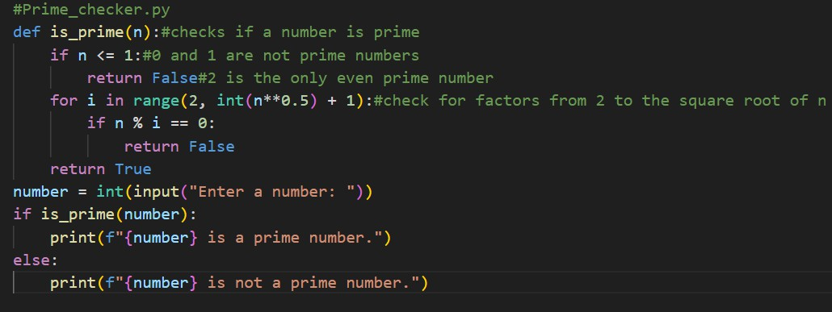
Output:

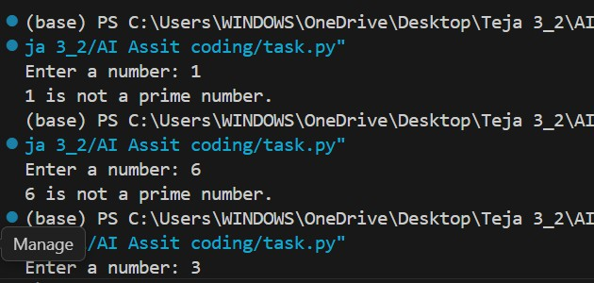
Observation:
AI-generated function summaries help improve code readability by clearly describing the purpose of each function. The summaries make it easier for developers to understand the program structure without analyzing the implementationdetails.Thisapproachalsosupportsfastermaintenanceand documentation consistency.

TaskDescription-2(Documentation–LogicalExplanationfor Conditions and Loops)
Prompt:
addabriefexplanationofthelogicbehindtheeachconditionandloop statements. Explain only decision - making and loop statements
Code:
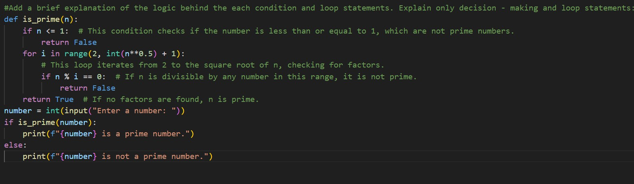
Output:

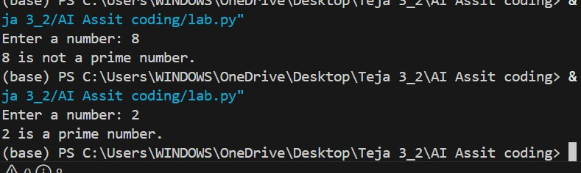
Observation:
AI-generatedexplanationsforconditionsandloopsclarifythedecision-making flow and iteration behavior within the program. These logical comments help users quickly understand how the program controls execution paths. As a result, debugging and code comprehension become more efficient.

TaskDescription-3(Documentation–File-LevelOverview) Prompt:
Generateafilesummarizingtheoverallfunctionalityofthescript,includingthe purpose of the main function and how it interacts with the user.
Code:
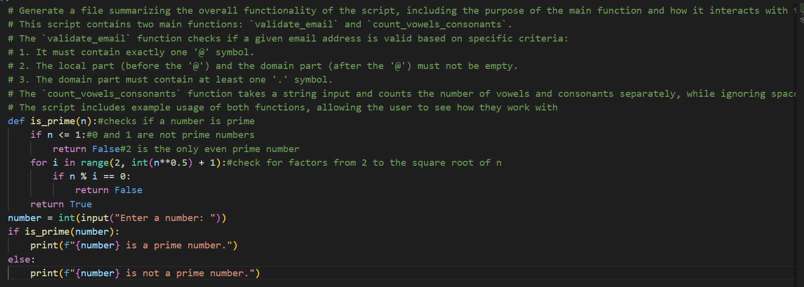
Output:

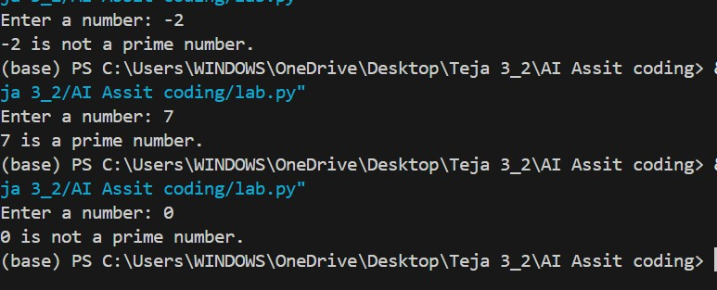
ScriptSummary:
Thisscriptdefinesafunctioncalledis_primethatcheckswhetheragiven number is a prime number or not.
Themainfunctionpromptstheusertoinputanumber,thencallstheis_prime function with the user's input.
Basedonthereturnvalueoftheis_primefunction,itprintsoutwhetherthe number is a prime number or not.
Thescriptusesbasiccontrolflowstatementstodeterminetheprimalityofthe number and provides feedback to the user accordingly.
Observation:
The AI successfully generated a concise file-level overview summarizing the overall purpose and functionality of the Python program. The overview was placedatthebeginningofthefileanddescribedtheprogramataconceptual levelwithoutincludingimplementationdetails.Thisimprovedthereadabilityof the code and helped users quickly understand the program’s objective.

TaskDescription-4(Documentation–RefineExistingDocumentation) Prompt:
Rewritetheexistingcommentstoimproveclarityandconsistencywhile keepingtheoriginalmeaningunchanged. Donotmodifytheprogramlogic.
Code:

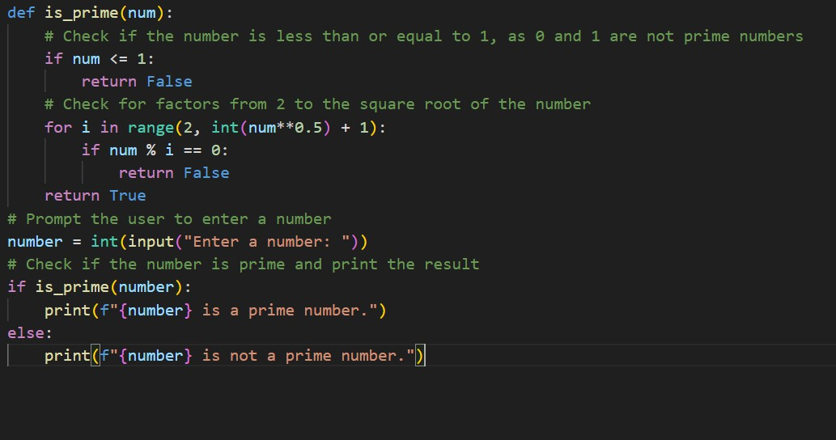
Output:
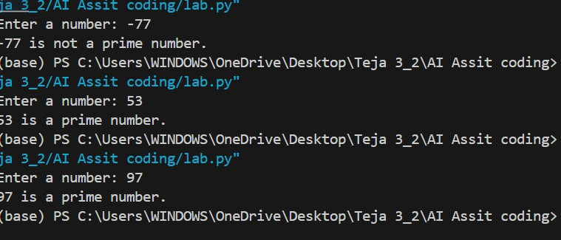
Observation: TheAIimprovedtheclarityandconsistencyoftheexistingcommentswithout altering the program’s functionality. The refined documentation provided clearer explanations while preserving the original technical meaning. This enhancement made the code easier to read, understand, and maintain.

TaskDescription-5(Documentation–PromptDetailImpactStudy) Brief Prompt:
Writeashortone-linedocumentationcommentdescribingthepurposeofthe following function.
Code:

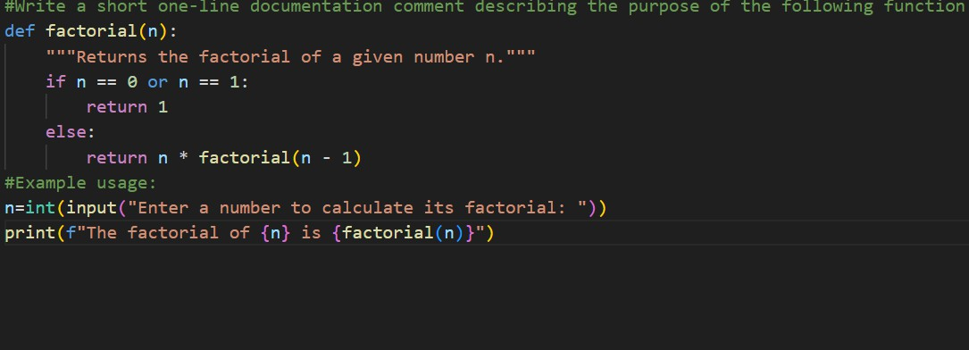
Output:
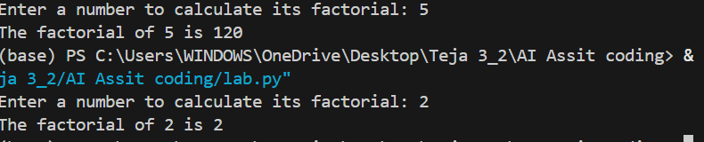
DetailedPrompt:
Writeaclear3–5linedocumentationcommentforthefollowingfunction describing its purpose, inputs, outputs, and overall behavior.
Code:
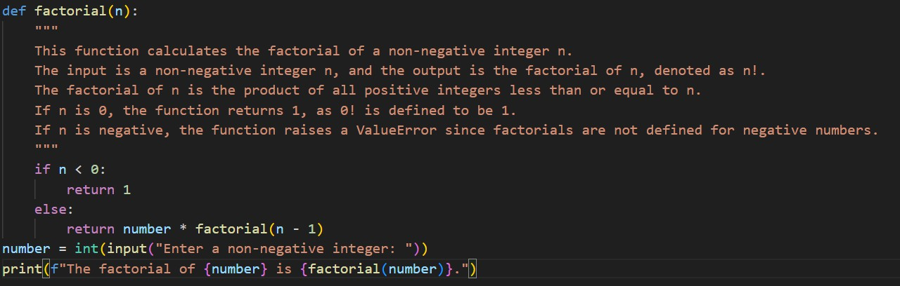

Output:
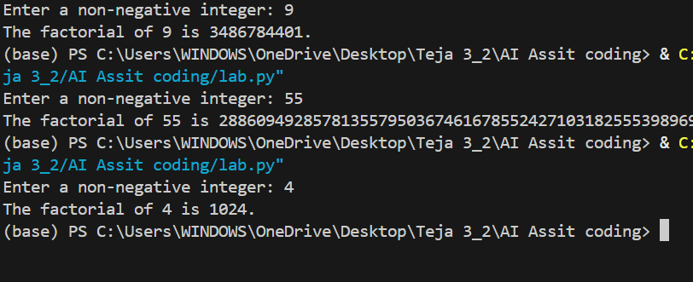
Observation:

Criteria | BriefPromptOutput(One-  lineComment) | DetailedPromptOutput(3–5line  Docstring)
Completeness | Provides only the basic purposeofthefunction. | Includes purpose, input description,output,andbehavior details.
Clarity | Clearbutveryminimal explanation. | Moredescriptive,structured,and easier to understand.
Accuracy | Correctbutlimited technicalinformation. | Highlyaccuratewithfulltechnical context and parameter details.

